2024 Hard & Fast Race Series
3rd August 2024
Ian Shaw Park Reserve, Mt Wellington
Ngā Hau Maiangi
Race 6

EVENT SUMMARY
Ngā Hau Maiangi welcomes you to the 2024 Hard & Fast race series to be held at Ngā Hau Maiangi, Ian Shaw Park Reserve, Auckland, on 3rd August 2024. Ngā Hau Maiangi Hard & Fast Race Series is a series of races run throughout our winter season to drive activity in winter months and keep waka ama a sport to choose and enjoy during the cooler months. This is to promote inclusion of all abilities and fitness levels from our more experienced to our novice paddlers as well as fostering a sense of belonging within our local community, bringing the waka ama community together as a whānau.
The event is a full day of fun racing, food vendors, and an end of series prize giving.
We welcome you and your whānau to join us for this event.

EVENT SCHEDULE

6.00am | Registration, waka drop off & safety checks
8.00am | Karakia
8.15am | Managers Meeting
8.30am | Race & safety briefings
9.00am | Racing starts
2.00pm | Racing finishes
2.30pm | Closing Karakia

RACE SCHEDULE

Time | Race
8.30am | Race & Safety Briefing - all races
9.00am | Race Start – W6 5km J16, Novice
10.00am | Race Start – W6 10 km J19, Senior

RACE DAY INFORMATION
Car Parking: Parking is available behind Ngā Hau Maiangi building. Please note all parking is under Auckland Council management, you will need to read the signs and park accordingly.
PLEASE NOTE: Strictly NO parking past the roundabout.
Trailer parking: Trailer parking will be in the field behind Ngā Hau Maiangi building. Due to restrictions, this will only be available for trailer drop off – you will need to park your car elsewhere for the day.
Food: We encourage you to bring your own healthy kai, however a small range of food vendors will be available onsite to purchase healthy kai.
Toilets: Toilets are located underneath the Ngā Hau Maiangi building.
First Aid: First Aid will be available at the registration area.
Rubbish/Recycling: We encourage you to please take what you bring. However, the main rubbish and recycling station is located down the ramp next to the bollards.
Alcohol/Smokefree: Alcohol, smoking, vaping and any other substance use is not permitted at this event, including all premises of the event.

WAKA DROP OFF & SAFETY CHECKS
Waka Drop off:
- Waka drop off will be available from 6.00am on the event day
- Waka drop off will be down the front on the ramp.
- Trailer parking is on the field behind the Ngā Hau Maiangi building, please be aware of your surroundings through this process.
Safety Checks:
- All waka will have to pass a safety check and be marked before racing. Any boats not marked
will not be permitted to race.

RACE RULES
All entrants must be familiar with the Waka Ama New Zealand race and safety rules.
Refer to the following link for more information: Waka Ama NZ Race Rules

AGE DIVISIONS & RACE EVENTS

WAKA | DISTANCE | DIVISIONS | GENDER
W6 | 5km | J16, Novice/mixed | Men & Women, Mixed
W6 | 10km | J19, Open, Master, Senior Master, Golden Master | Men, Women

FEES

PER PERSON BY EVENT (charged for each event entered)
Event | Cost
W6 - 5km | $15.00
W6 - 10km | $25.00

ONLINE ENTRIES & PAYMENT
- Online entries are to be completed using the Waka Ama NZ online entry system.
- All entries are to be completed through your club admin – contact your club admin to process your entry
- No entries on the day, no exceptions
- Entries close on Wed 30th July 2024 @ 11.59 pm
- Rosters close on Thur 31st July 2024 @ 11.59 pm, rosters must be completed by the close date, no exceptions. There will be NO late entries accepted.
Any late entries on the day will incur a late fee charge of $50 per team.
- Once entered, payment can be made online to:
  - Ngā Hau Maiangi
  - Hard n Fast Acct 50 / Acct# 12-32870326561-50
  - Use your club, team name, and division as your reference

PLEASE NOTE:
There will be no refunds for any teams that withdraw from racing once registration has closed.

SAFETY REQUIREMENTS
- All waka must be Safety-checked
- All Junior age divisions must wear life jackets
- All Junior (J16 & J19) and Senior (Open and above) must have the following safety equipment for their races:
  - PFD - Personal Floatation Device (per person)
  - Bailers
  - Flare or cellphone in waterproof case
  - Spare Paddle - 2 for a W6
  - Spray Skirt if required (W6)
  - Tow Rope (W6)

INDIVIDUAL & TEAM WAIVERS
- Team waivers must be completed by all paddlers/teams
- All paddlers U18 must have their waiver signed by their parent/guardian
- Waivers can be sent to nhminc.secretary@gmail.com or handed in at the managers' meeting on the day
- Team waivers can be found on our event page on the Waka Ama NZ website

CONTACT INFORMATION
- For all inquiries please email: nhminc.secretary@gmail.com
- For all urgent matters please call: 0273208980

COURSE MAPS

- High tide:6.03am
- Low tide:12.16pm

MAP 2: 5KM Racecourse
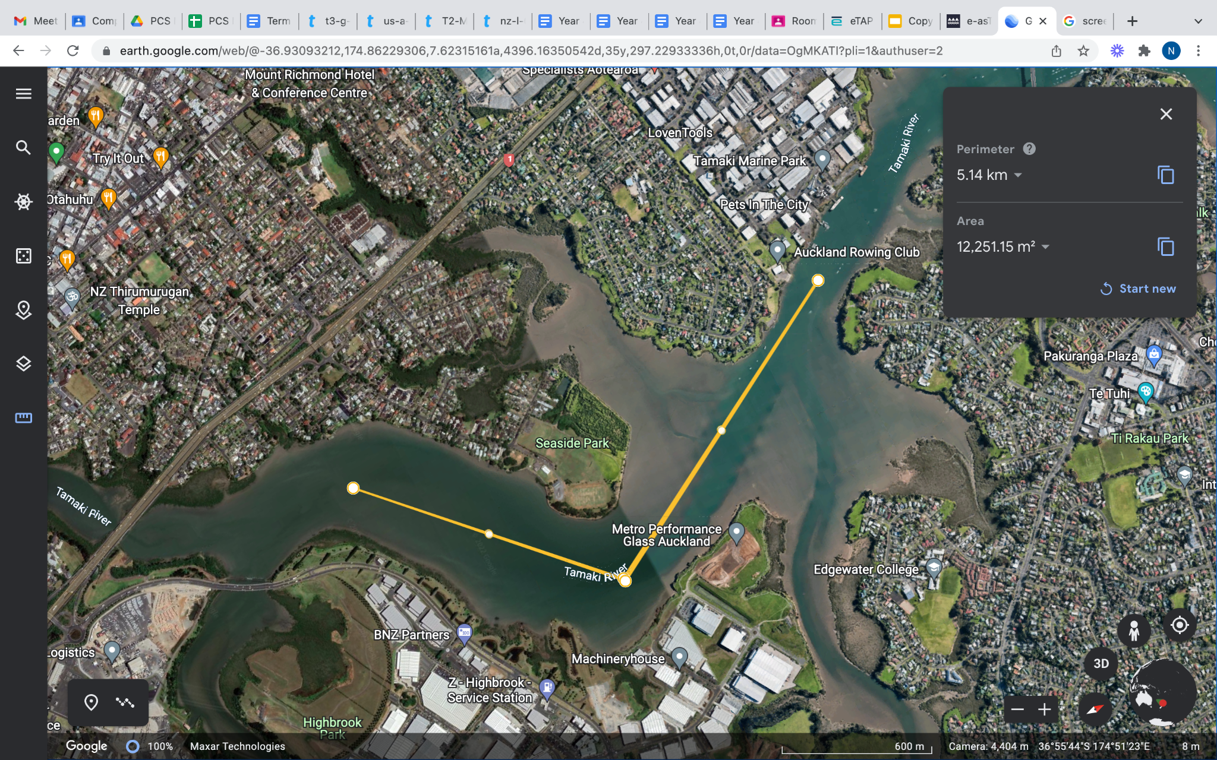

Start/Finish – The Ramp

Buoy 1
Turning Buoy

MAP 2: 10KM Racecourse

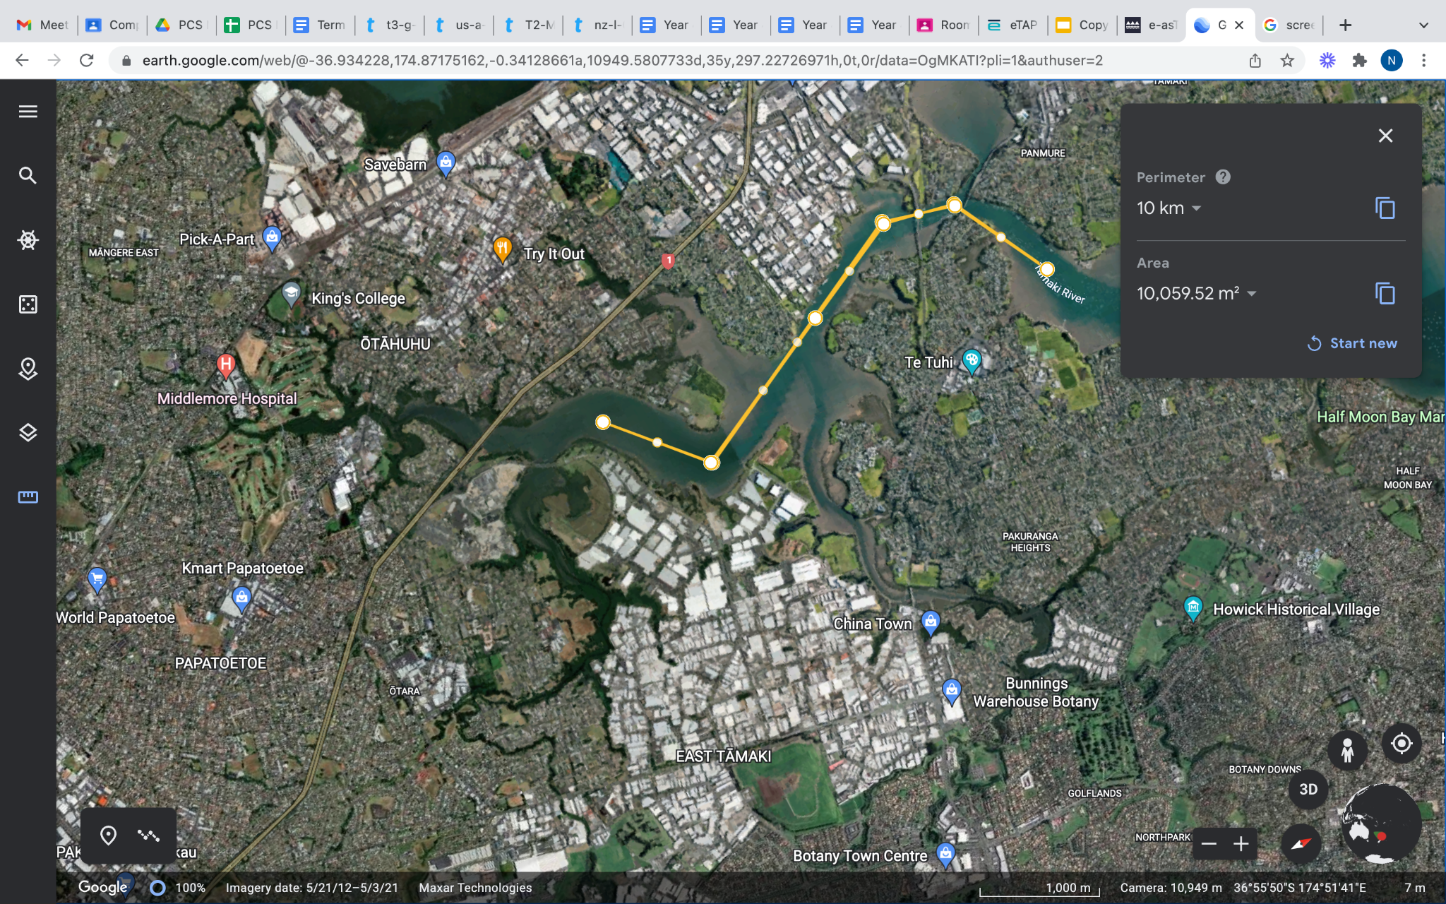

S Start/Finish - The Ramp

First Turn
Second Turn

MAP 2: Alternative Racecourse/s
Please note: In the event of bad weather the main course will not go ahead therefore there will be no alternative course and all racing will be cancelled.

